***Connecting to Your Home WiFi***

***How to get your computer to connect to your home Wi-Fi***

1. On your laptop, click on the computer icon in the bottom right hand corner



2. Click on the “Network” tab

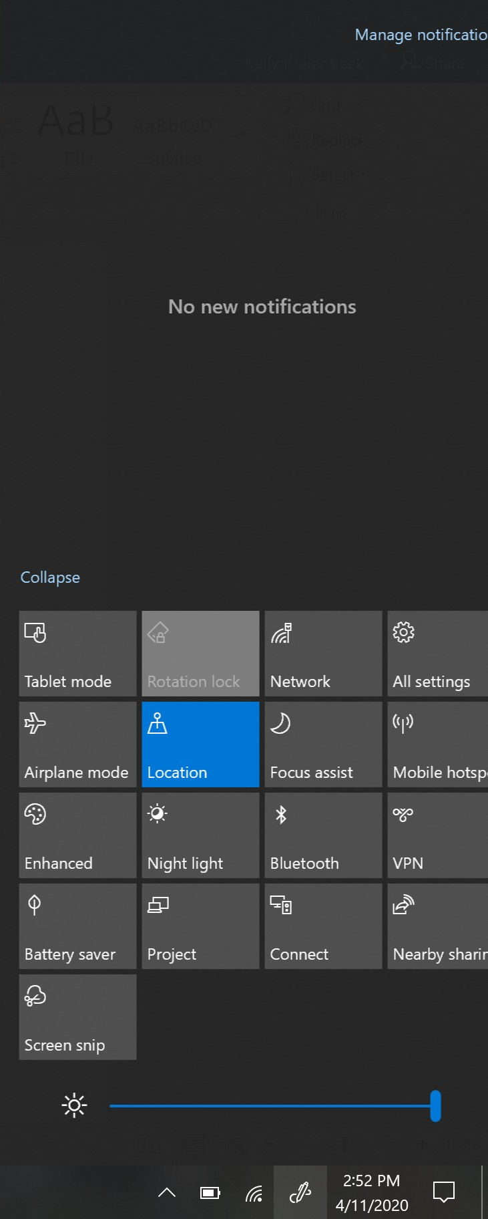

3. Find your listed Wi-Fi name

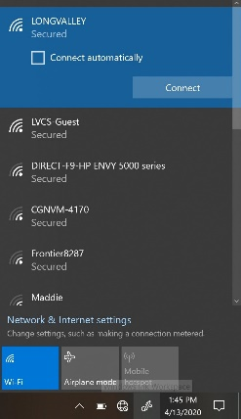

4. Click connect

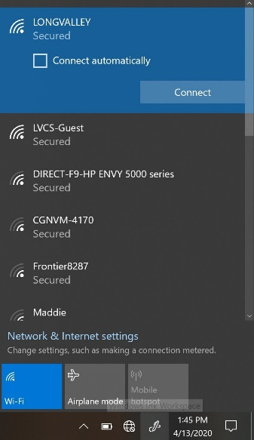

5. Enter in passcode for wireless internet

6. If you are connected you will see this symbol 